EXP NO 1: CREATE A SIMPLE CLOUD SOFTWARE APPLICATION AND PROVIDE IT AS A SERVICE USING ANY CLOUD SERVICE PROVIDER TODEMONSTRATE SOFTWARE AS A SERVICE (SAAS).

PROCEDURE:
STEP1: GOTO ZOHO.COM
STEP 2: LOGIN TO THE ZOHO.COM STEP 3: SELECT ONE APPLICATION STEP 4: ENTER APPLICATION NAME STEP 5: CREATED NEW APPLICATION STEP 6: SELECT ONE FORM
STEP 7: THE SOFTWARE HASE BEEN CREATED.

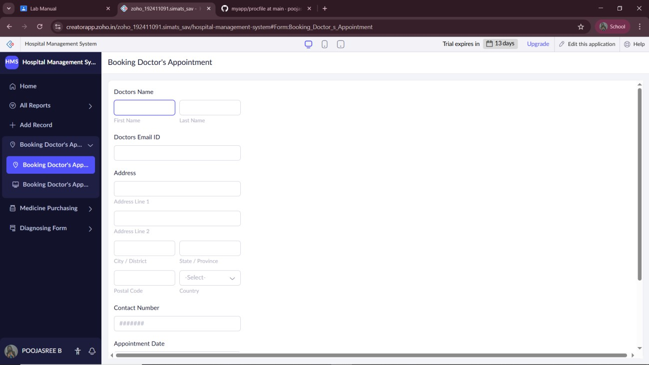
SAMPLE OUTPUT(Without Data)

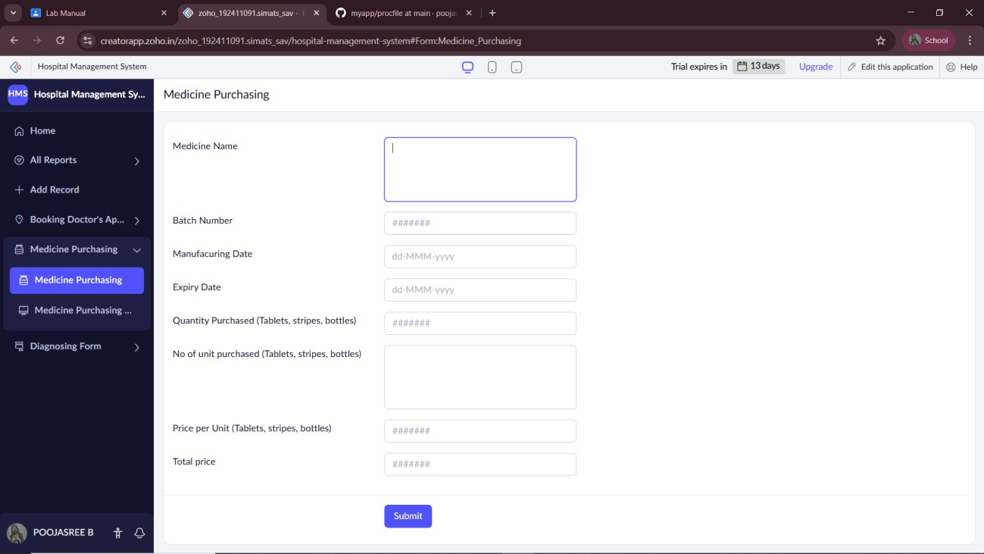
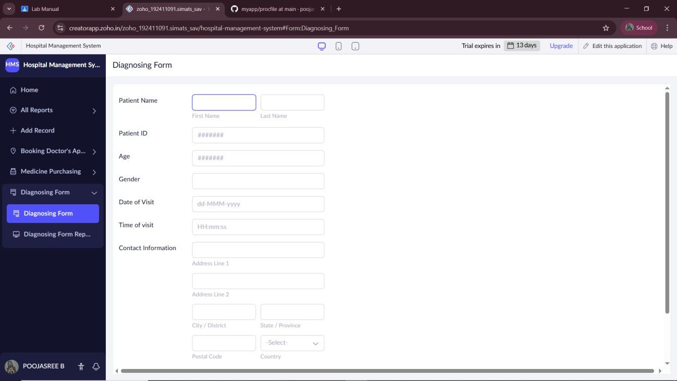

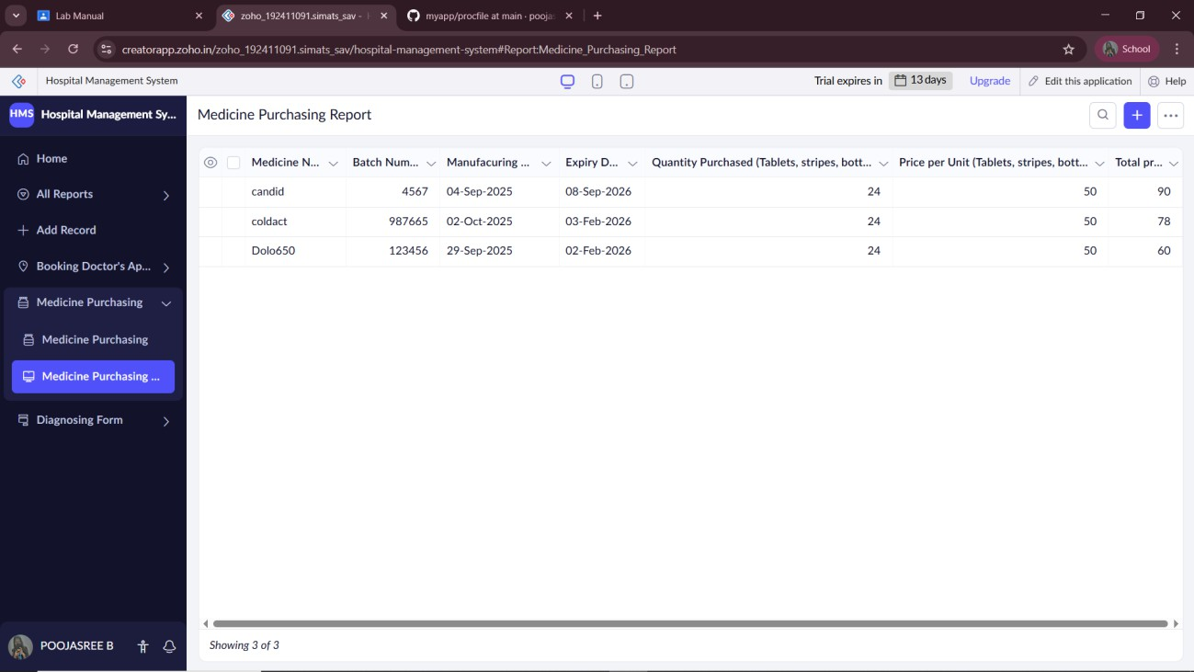
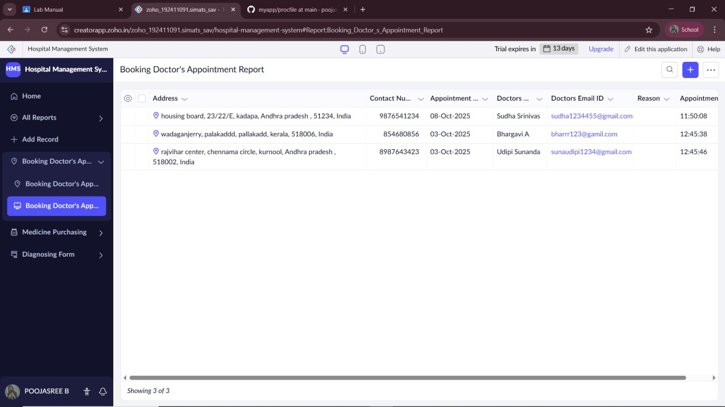
SAMPLE OUTPUT (with Data)

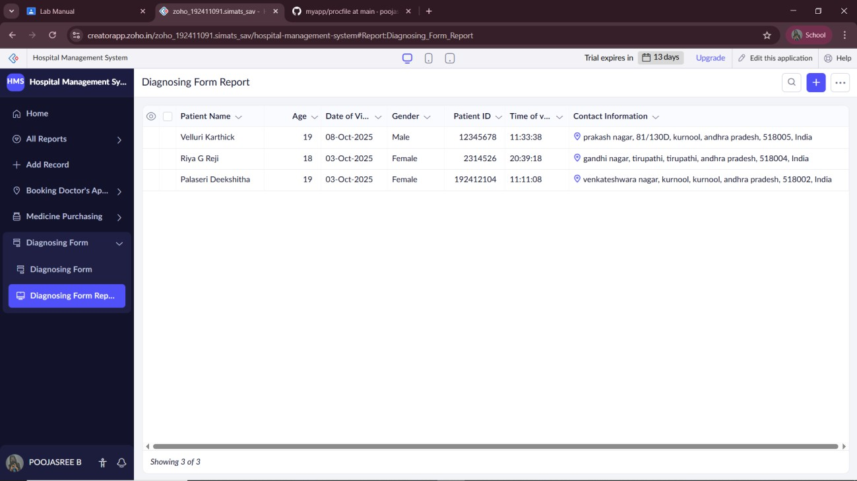

RESULT
Thus the Hospital Management System is implemented using Zoho Software.

